Family History genetics is moving very rapidly so that many changes have taken place during 2015. This document explains the three (3) trees dated 5/6Jan16. YFull and FGC (Full Genome Corp) are the 2 leading Ydna tree generators. YFull (a Russian lab) gave me their analysis of my Big Y results which showed Rene’s twig. It will remain a twig until someone else show the same unique mutation I (and 17 other sons of Rene) carry which today is only identified as a location on the Y chromosome (2,735,751). There are about 20 more of these novel variants. The one shown is the lowest location arbitrarily selected for now.

It may take years to standardize which SNP ultimately identifies a specific father in the human Y tree. Each lab decides to label it as they wish and the tree is growing so fast, no one has time to keep it updated. ISOGG (International Society of Genetic Genealogy) will eventually make a selection. For now a father may have up to 1,000 SNP names. Each lab may find several mutations that are equivalent for any father.
A father’s formal name is the SNP (single nucleotide polymorphism) that is finally standardized. A nickname cannot keep up with the SNPs. Rene’s genetic grandfather at present P109’s nickname is not standardized. It used to be I1a1b1a3.

These 2 labs and a guru (Ray Banks) generate the best trees. Ray’s tree is called Composite Y tree - https://sites.google.com/site/compositeytree/home.
YFull’s tree can be found at http://www.yfull.com/tree/ and
FGC’s tree can be found at https://www.fullgenomes.com/

1 tree (2 pages) is taken from FGC to show Rene’s descent from Adam.
1 tree is generated in EXCEL to show the SNPs from Adam to Rene where some are common to both YFull and FGC and some are not.

The years before present that each father lived will be changing as new twigs and branches form on the tree.

Y-MRCA
In human genetics, Y-chromosomal most recent common ancestor (Y-MRCA; informally also known as Y-chromosomal Adam) refers to the most recent common ancestor (MRCA) from whom all currently living people are descended patrilineally. The term Y-MRCA reflects the fact that the Y chromosomes of all currently living males are directly derived from the Y chromosome of this remote ancestor. The analogous concept of the matrilineal most recent common ancestor is known as "Mitochondrial Eve" (mt-MRCA, named for the matrilineal transmission of mtDNA), the most recent woman from whom all living humans are descended matrilineally.
By the nature of the concept of most recent common ancestors, these estimates can only represent a terminus ante quem ("limit before which"), until the genome of the entire population has been examined (in this case, the genome of all living humans). In 2013, the discovery of a previously unknown Y-chromosomal haplogroup was announced, which resulted in a slight adjustment of the estimated age of the human Y-MRCA.
Current estimates of the Y-MRCA range around 200,000 to 300,000 years ago, consistent with the emergence of anatomically modern humans and overlapping with age estimates for the mt-MRCA (matri-linear MRCA).
By definition, it is not necessary that the Y-MRCA and the mt-MRCA should have lived at the same time, even though current (as of 2014) estimates suggest the possibility that the two individuals may well have been roughly contemporaneous (albeit with uncertainties ranging in the tens of thousands of years).

Definition
The existence of a Y-MRCA for any given human population is a consequence of the fact that every human being has a biological father, and that every human male inherits his Y chromosome from his biological father. We assume quite reasonably that every man inherited his Y chromosome from some common ancestor (say, the first creature to have a Y chromosome). So there had to be a male who was the last one from whom all men inherit their Y chromosome. (It is not a logical necessity that that male was a Homo sapiens however.)
Although the informal name "Y-chromosomal Adam" is a reference to the biblical Adam, this should not be misconstrued as implying that the bearer of the chromosome was the only human male alive during his time. His other male contemporaries also have descendants alive today, but not, by definition, through solely patrilineal descent.
Due to the definition via the "currently living" population, the identity of a MRCA, and by extension of the human Y-MRCA, is time-dependent (it depends on the moment in time intended by the term "currently"). The MRCA of a population may move forward in time as archaic lineages within the population go extinct: once a lineage has died out, it is irretrievably lost. This mechanism can thus only shift the title of Y-MRCA forward in time. Such an event could be due to the total extinction of several basal haplogroups. The same holds for the concepts of matrilineal and patrilineal MRCAs: it follows from the definition of Y-MRCA that he had at least two sons who both have unbroken lineages that have survived to the present day. If the lineages of all but one of those sons die out, then the title of Y-MRCA shifts forward from the remaining son through his patrilineal descendants, until the first descendant is reached who had at least two sons who both have living, patrilineal descendants. The title of Y-MRCA is not permanently fixed to a single individual, and the Y-MRCA for any given population would himself have been part of a population which had its own, more remote, Y-MRCA.

Age estimate
In addition to the tendency of the title of Y-MRCA to shift forward in time, the estimate of the Y-MRCA's DNA sequence, his position in the family tree, the time when he lived, and his place of origin, all are subject to future revisions.
The following events would change the estimate of the individual designated as Y-MRCA was:
- Further sampling of Y chromosomes could uncover previously unknown divergent lineages. If this happens, Y-chromosome lineages would converge on an individual who lived further back in time.
- The discovery of additional deep rooting mutations in known lineages could lead to a rearrangement of the family tree.
- Revision of the Y-chromosome mutation rate (see below) can change the estimate of the time when he lived.

Method
The time when Y-MRCA lived is determined by applying a molecular clock to human Y-chromosomes. In contrast to mitochondrial DNA, which has a short sequence of 16,000 base pairs, and mutates frequently, the Y chromosome is significantly longer at 60 million base pairs, and has a lower mutation rate. These features of the Y chromosome have slowed down the identification of its polymorphisms; as a consequence, they have reduced the accuracy of Y-chromosome mutation rate estimates.
Methods of estimating the age of the Y-MRCA for a population of human males whose Y-chromosomes have been sequenced are based on applying the theories of molecular evolution to the Y chromosome. Unlike the autosomes, the human Y-chromosome does not recombine often with the X chromosome during meiosis, but is usually transferred intact from father to son; however, it can recombine with the X chromosome in the pseudo-autosomal regions at the ends of the Y chromosome. Mutations occur periodically within the Y chromosome, and these mutations are passed on to males in subsequent generations.
These mutations can be used as markers to identify shared patrilineal relationships. Y chromosomes that share a specific mutation are referred to as haplogroups. Y chromosomes within a specific haplogroup are assumed to share a common patrilineal ancestor who was the first to carry the defining mutation. (This assumption could be mistaken, as it is possible for the same mutation to occur more than once.) A family tree of Y chromosomes can be constructed, with the mutations serving as branching points along lineages. The Y-MRCA is positioned at the root of the family tree, as the Y chromosomes of all living males are descended from his Y chromosome.
Researchers can reconstruct ancestral Y chromosome DNA sequences by reversing mutated DNA segments to their original condition. The most likely original or ancestral state of a DNA sequence is determined by comparing human DNA sequences with those of a closely related species, usually non-human primates such as chimpanzees and gorillas. By reversing known mutations in a Y-chromosome lineage, a hypothetical ancestral sequence for the MRCA, Y-chromosomal Adam, can be inferred.
Determining the Y-MRCA's DNA sequence, and the time when he lived, involves identifying the human Y-chromosome lineages that are most divergent from each other—the lineages that share the fewest mutations with each other when compared to a non-human primate sequence in a phylogenetic tree. The common ancestor of the most divergent lineages is therefore the common ancestor of all lineages.

Estimates
Current (as of 2015) estimates for the age for the Y-MRCA are roughly compatible with the estimate for the emergence of anatomically modern humans some 200,000 years ago (200 kya), although there are substantial uncertainties.
Early estimates published during the 1990s ranged between roughly 200 and 300 kya, Such estimates were later substantially corrected downward, as in Thomson et al. 2000, which proposed an age of about 59,000. This date suggested that the Y-MRCA lived about 84,000 years after his female counterpart mt-MRCA (the matrilineal most recent common ancestor), who lived 150,000–200,000 years ago. This date also meant that Y-chromosomal Adam lived at a time very close to, and possibly after, the migration from Africa which is believed to have taken place 50,000–80,000 years ago. One explanation given for this discrepancy in the time depths of patrilineal vs. matrilineal lineages was that females have a better chance of reproducing than males due to the practice of polygyny. When a male individual has several wives, he has effectively prevented other males in the community from reproducing and passing on their Y chromosomes to subsequent generations. On the other hand, polygyny does not prevent most females in a community from passing on their mitochondrial DNA to subsequent generations. This differential reproductive success of males and females can lead to fewer male lineages relative to female lineages persisting into the future. These fewer male lineages are more sensitive to drift and would most likely coalesce on a more recent common ancestor. This would potentially explain the more recent dates associated with the Y-MRCA.
The "hyper-recent" estimate of significantly below 100 kya was again corrected upward in studies of the early 2010s, which ranged at about 120 kya to 160 kya. This revision was due to the discovery of additional mutations and the rearrangement of the backbone of the Y-chromosome phylogeny following the re-sequencing of Haplogroup A lineages. In 2013, Francalacci et al. reported the sequencing of male-specific single-nucleotide Y-chromosome polymorphisms (MSY-SNPs) from 1204 Sardinian men, which indicated an estimate of 180,000 to 200,000 years for the common origin of all humans through paternal lineage. or again as high as 180 to 200 kya. Also in 2013, Poznik et al. reported the Y-MRCA to have lived between 120,000 and 156,000 years ago, based on genome sequencing of 69 men from 9 different populations. In addition, the same study estimated the age of Mitochondrial Eve to about 99,000 and 148,000 years. As these ranges overlap for a time-range of 28,000 years (148 to 120 kya), the results of this study have been cast in terms of the possibility that "Genetic Adam and Eve may have walked on Earth at the same time" in the popular press.
The announcement of yet another discovery of a previously unknown lineage, haplogroup A00, in 2013, resulted in another shift in the estimate for the age of Y-chromosomal. Karmin et al. (2015) dated it to between 192,000 and 307,000 years ago (95% CI). The same study reports that non-African populations converge to a cluster of Y-MRCAs in a window close to 50kya (out-of-Africa migration), and an additional bottleneck for non-African populations at about 10kya, interpreted as reflecting cultural changes increasing the variance in male reproductive success (i.e. increased social stratification) in the Neolithic.
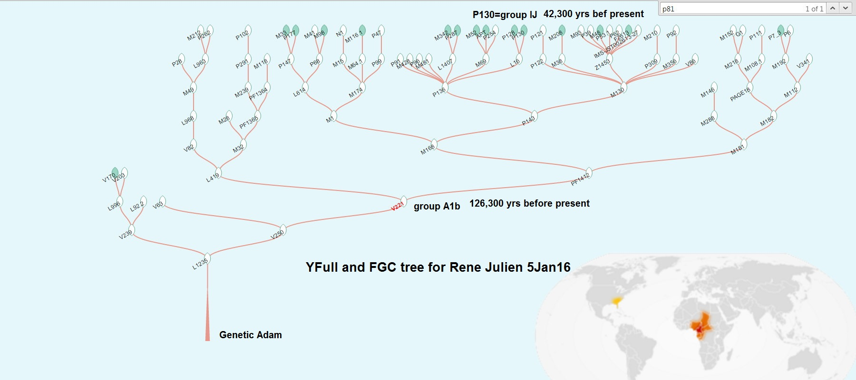
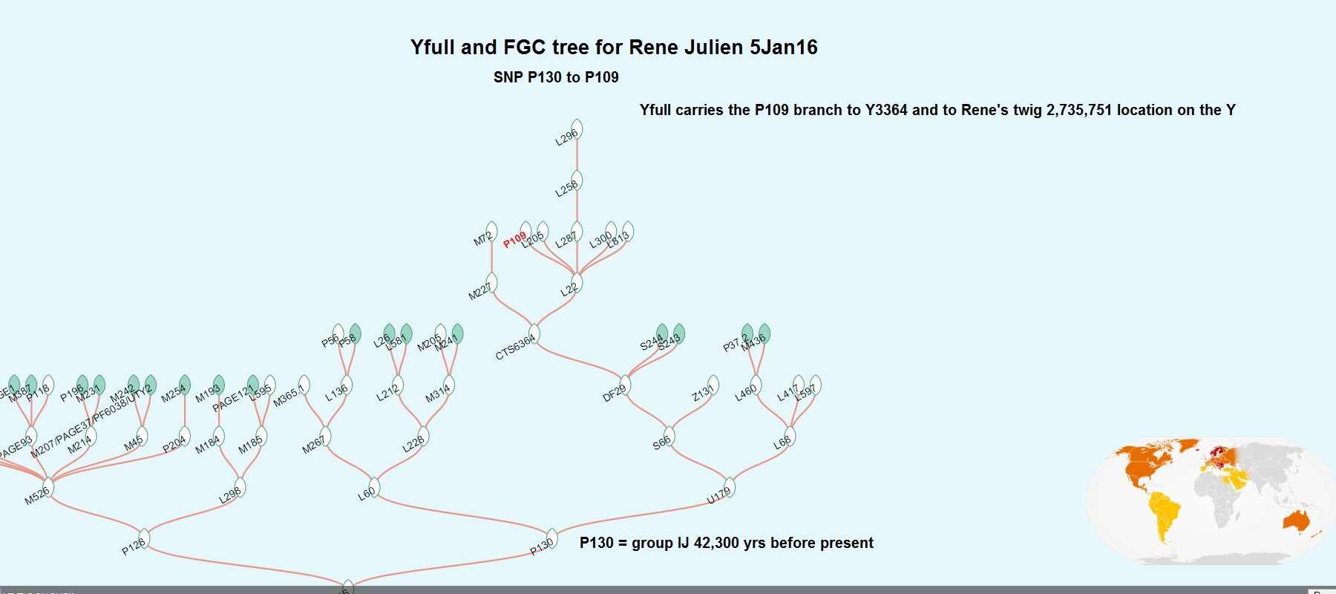

YFull and FGC tree for Rene Julien 6Jan16

Adam
 | A00 | 192 – 307,000
 | A0-T | YP2191 - 146,300
 |  | A0
 |  | A1
 |  |  | A1a
 |  |  | A1b | V221 - 126,300
 |  |  |  | A1b1
 |  |  |  | BT
 |  |  |  |  |  | B
 |  |  |  |  |  | CT
 |  |  |  |  |  |  | DE
 |  |  |  |  |  |  |  | D
 |  |  |  |  |  |  |  | E
 |  |  |  |  |  |  | CF | P143 - 65,400
 |  |  |  |  |  |  |  | C
 |  |  |  |  |  |  |  | F | M481 - 47,900
 |  |  |  |  |  |  |  |  | F1
 |  |  |  |  |  |  |  |  | F2
 |  |  |  |  |  |  |  |  | F3
 |  |  |  |  |  |  |  |  | GHIJK
 |  |  |  |  |  |  |  |  |  | G | U12 - 26,300
 |  |  |  |  |  |  |  |  |  | HIJK
 |  |  |  |  |  |  |  |  |  |  | H | Z4221 - 45,300
 |  |  |  |  |  |  |  |  |  |  | IJK
 |  |  |  |  |  |  |  |  |  |  |  | IJ |  | P130 - 42,400
 |  |  |  |  |  |  |  |  |  |  |  |  | I | L772 - 27,800
 |  |  |  |  |  |  |  |  |  |  |  |  |  | I1 | FGC2435 - 4,700
 |  |  |  |  |  |  |  |  |  |  |  |  |  |  | I1a DF29 - 4,700
 |  |  |  |  |  |  |  |  |  |  |  |  |  |  | Z2337/S6346 - 4,100
 |  |  |  |  |  |  |  |  |  |  |  |  |  |  | P109 - 3,400
 |  |  |  |  |  |  |  |  |  |  |  |  |  |  | Y3364/FGC23778 - 3,400
 |  |  |  |  |  |  |  |  |  |  |  |  |  |  | Rene - 2,735,751 - no match yet – yBp TBD
 |  |  | left to right - nickname, SNP, father lived years before present

